Firm No.: 59049

IN THE CIRCUIT COURT OF COOK COUNTY, ILLINOIS
COUNTY DEPARTMENT - CHANCERY DIVISION

THE BANK OF NEW YORK MELLON F/K/A THE BANK OF NEW YORK, AS TRUSTEE FOR THE CERTIFICATEHOLDERS OF CWALT, INC., ALTERNATIVE LOAN TRUST 2005-50CB, MORTGAGE PASS-THROUGH CERTIFICATES, SERIES 2005-50CB
Plaintiff, | Case No. 18 CH 05384  Cal No.: 60
vs.
vs. | Property Address:  6924 W. 113th St.
ROBERT STARR A/K/A ROBERT E. STARR; KIMBERLEY STARR A/K/A KIMBERLEY A. STARR; ROBERT E. STARR, AS TRUSTEE OF THE JENNIFER VIVIAN LIVING TRUST DATED FEBRUARY 8, 2013; STATE OF ILLINOIS; BRANDON HAWKINS; THE UNITED STATES OF AMERICA, OFFICE OF THE DEPARTMENT OF THE TREASURY; THE BANK OF NEW YORK MELLON F/K/A THE BANK OF NEW YORK, AS SUCCESSOR TRUSTEE TO JPMORGAN CHASE BANK, N.A., AS TRUSTEE ON BEHALF OF THE CERTIFICATEHOLDERS OF THE CWHEQ INC., CWHEQ REVOLVING HOME EQUITY LOAN TRUST, SERIES 2006-A; UNKNOWN OWNERS AND NON-RECORD CLAIMANTS; | Worth, IL 60482
Defendant(s).

NOTICE OF FILING
TO: See Attached Service List
PLEASE TAKE NOTICE that on May 11, 2018, our office filed with Clerk of the Circuit Court of
Cook County our Appearance and Answer, a copy of which is attached hereto and served upon you.
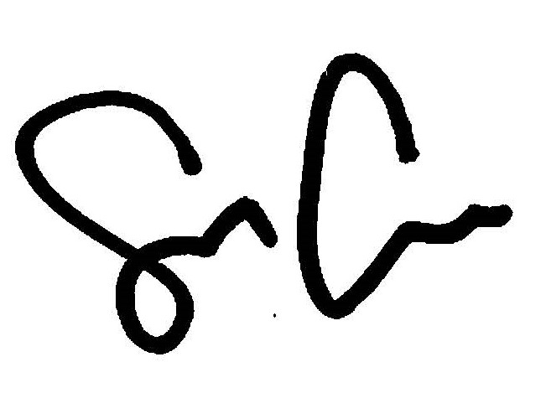
By: ___________________________________
Shaun Callahan/ARDC#6296022
Attorney, Marinosci Law Group, P.C.
Firm No.: 59049

CERTIFICATE OF SERVICE

I, Shaun Callahan, hereby certify under penalty of perjury and 735 ILCS Sec. 1-109, that I caused to be served on the members of the attached service list, the attached document(s), by mailing a copy via electronic mail or via US Mail, postage pre-paid at 134 N. LaSalle St., Chicago, Illinois on May 11, 2018, before the hour of 5:00 p.m., as so noted below.
By: _________________________________
Shaun Callahan/ARDC#6296022
Attorney, Marinosci Law Group, P.C.
Firm No.: 59049
MARINOSCI LAW GROUP, P.C.
134 N. LaSalle Street, Suite 1900, Chicago, IL 60602
Telephone: 312-940-8580; Fax: 401-234-5130
Firm No.: 59049
mlgil@mlg-defaultlaw.com

SERVICE LIST

MANLEY DEAS KOCHALSKI LLC
Via Electronic Mail to: MDKIllinoisFilings@manleydeas.com

Firm No.: 59049

IN THE CIRCUIT COURT OF COOK COUNTY, ILLINOIS
COUNTY DEPARTMENT - CHANCERY DIVISION

THE BANK OF NEW YORK MELLON F/K/A THE BANK OF NEW YORK, AS TRUSTEE FOR THE CERTIFICATEHOLDERS OF CWALT, INC., ALTERNATIVE LOAN TRUST 2005-50CB, MORTGAGE PASS-THROUGH CERTIFICATES, SERIES 2005-50CB
Plaintiff, | Case No. 18 CH 05384  Cal No.: 60
vs.
vs. | Property Address:  6924 W. 113th St.
ROBERT STARR A/K/A ROBERT E. STARR; KIMBERLEY STARR A/K/A KIMBERLEY A. STARR; ROBERT E. STARR, AS TRUSTEE OF THE JENNIFER VIVIAN LIVING TRUST DATED FEBRUARY 8, 2013; STATE OF ILLINOIS; BRANDON HAWKINS; THE UNITED STATES OF AMERICA, OFFICE OF THE DEPARTMENT OF THE TREASURY; THE BANK OF NEW YORK MELLON F/K/A THE BANK OF NEW YORK, AS SUCCESSOR TRUSTEE TO JPMORGAN CHASE BANK, N.A., AS TRUSTEE ON BEHALF OF THE CERTIFICATEHOLDERS OF THE CWHEQ INC., CWHEQ REVOLVING HOME EQUITY LOAN TRUST, SERIES 2006-A; UNKNOWN OWNERS AND NON-RECORD CLAIMANTS; | Worth, IL 60482
Defendant(s).

ANSWER TO COMPLAINT TO FORECLOSE MORTGAGE

NOW COMES Defendant, THE BANK OF NEW YORK MELLON F/K/A THE BANK OF NEW YORK, AS SUCCESSOR TRUSTEE TO JPMORGAN CHASE BANK, N.A., AS TRUSTEE ON BEHALF OF THE CERTIFICATEHOLDERS OF THE CWHEQ INC., CWHEQ REVOLVING HOME EQUITY LOAN TRUST, SERIES 2006-A, by and through its attorneys, MARINOSCI LAW GROUP, P.C. and in answer to the Complaint in the above-captioned case states as follows:
1. Defendant admits the allegations in paragraph 1.
2. Defendant neither admits nor denies paragraph 2, since it has insufficient knowledge to form a belief as to the truth thereof, but demand strict proof of same.
3. Defendant neither admits nor denies paragraph 3, since it has insufficient knowledge to form a belief as to the truth thereof, but demand strict proof of same.
4. Defendant neither admits nor denies paragraph 4, subparagraphs (A), (B), (C), (D), (E), (F), (G), (H), (I), (J), (K) since it has insufficient knowledge to form a belief as to the truth thereof, but demands strict proof of same.
5. Defendant admits the allegations in paragraph 4, subparagraph (L), furthermore, attached as Exhibit A to its Answer is a true and correct copy of its recorded Mortgage. Said mortgage is a valid second lien on the subject premises, subordinate only to the first lien held by THE BANK OF NEW YORK MELLON F/K/A THE BANK OF NEW YORK, AS TRUSTEE FOR THE CERTIFICATEHOLDERS OF CWALT, INC., ALTERNATIVE LOAN TRUST 2005-50CB, MORTGAGE PASS-THROUGH CERTIFICATES, SERIES 2005-50CB.
6. Defendant neither admits nor denies paragraph 4 subparagraphs (M), (N), (O), (P), (Q), (R), (S), since it has insufficient knowledge to form a belief as to the truth thereof, but demands strict proof of same.
WHEREFORE, Defendant, THE BANK OF NEW YORK MELLON F/K/A THE BANK OF NEW YORK, AS SUCCESSOR TRUSTEE TO JPMORGAN CHASE BANK, N.A., AS TRUSTEE ON BEHALF OF THE CERTIFICATEHOLDERS OF THE CWHEQ INC., CWHEQ REVOLVING HOME EQUITY LOAN TRUST, SERIES 2006-A, prays that this Court:
- Find that Defendant has a valid and enforceable lien on the subject property, subordinate only to that of Plaintiff;
- Include Defendant’s interest in any judgment of foreclosure and sale entered herein;
- Allow Defendant to offset its debt against its bid in the event that Defendant bids at judicial sale;
- Grant any further relief the Court deems just and equitable.

Respectfully submitted,

By: ___________________________________
Shaun Callahan/ARDC#6296022
Attorney, Marinosci Law Group, P.C.
Firm No.: 59049
MARINOSCI LAW GROUP, P.C.
134 N. LaSalle Street
Suite 1900
Chicago, IL 60602
Telephone: 312-940-8580
Fax: 401-234-5130
Firm No.: 59049
mlgil@mlg-defaultlaw.com

